**Industrial Internship Report on**

**“Music Player Application”**

**Prepared By**

**Harshit Gulati**

|  |
| --- |
| *Executive Summary* |
| This report provides details of the Industrial Internship provided by upskill Campus and The IoT Academy in collaboration with the industrial partner UniConverge Technologies Pvt. Ltd. (UCT).  This internship was focused on a project/problem statement provided by UCT. We had to finish the project including the report in 6 weeks’ time.  My project was **Music Player Application** which is a prototype of Music player with songs and album part including other basic functionalities.  This internship gave me a very good opportunity to get exposure to industrial problems and design/implement solution for that. It was an overall great experience to have this internship. |

Table of Contents

1. Preface 3

2. Introduction 3

2.1 Background and context of the project 3

2.2 Importance of Banking Information Systems 4

2.3 Scope and objectives of the project 5

2.4 References 6

2.5 Glossary 7

3. Problem Statement 7

4. Existing and Proposed solution 8

5. Proposed Design/Model 9

5.1 High Level Diagram 9

5.2 Interfaces 11

6. Performance Test 11

6.1 Test Plan/Test Cases 13

6.2 Performance Outcome 14

7. My learnings 14

8. Future work scope 15

# 1. Preface

The “Music Player Application Project Report” presents a comprehensive overview of the development and implementation of the project over the 6 weeks. Each week included some progress in the development of the application and planning for the enhancements for the next week. All In the pages that follow, we delve into the intricacies of our Music Player Application, outlining its objectives, design principles, development methodology, and the challenges we encountered along the way. From conceptualization to deployment, every stage of this project offered unique insights and learning opportunities. The Music Player Application project aims to develop a prototype of an android based application system with responsive GUI. The prototype demonstrates the core features and flow of the system, showcasing its functionality and usability.

I owe my gratitude to the **upskill Campus** and **The IoT Academy** along with the industrial partner **UniConverge Technologies (UCT)** for providing me with this internship opportunity which was a 6-week internship program in which I was guided by the help team of the upskill Campus in almost all tasks, from reminders for submitting weekly progress report to attempting quizzes.

From this opportunity I learned how to interact with cooperate professionals and well as I learned new technologies that were used to develop my project. I give my best wishes to my juniors and other peers that are working or in future will get the opportunity to work with upskill Campus.

# 

# 2. Introduction

## 2.1 Background and context of the project

This music player app was born out of my passion for both technology and music. Throughout its development, I've focused on creating a user-friendly interface that prioritizes simplicity and elegance. Users can effortlessly navigate their music libraries, create playlists, and enjoy their favourite tunes with just a few taps.

This project has been an incredible journey of learning and growth for me. From mastering Android development frameworks to diving into user experience design, I've embraced every challenge to create an app that I'm genuinely proud of.

As we move forward, I'm excited to share this application with you and to receive feedback that will help me refine and improve it further. Thank you for your time, and I look forward to showcasing the features and capabilities of my Android-based Music Player Application."

**(I) Challenges in Traditional Music System:**

Traditional music systems often suffer from manual processes, limited accessibility, and unmanaged data. These limitations can result in inefficiencies, and hindered customer experiences. Moreover, as the volume of songs and data continues to grow exponentially, conventional methods of managing songs becomes increasingly inadequate. This project acts as a prototype to understand and manage songs with the help of Album Section and sorting options.

## 2.2 Importance of Music Application Systems

A music player application holds significant importance in today's digital landscape due to its role in shaping the way people consume and enjoy music. Here are some key reasons highlighting the importance of a music player application:

**1. Personalized Music Experience**: Music player applications allow users to curate their playlists, helping them tailor their music listening experience to their preferences, moods, and activities. Users can create playlists for workouts, relaxation, commuting, or parties, enhancing the emotional connection they have with the music.

**2. Accessibility to a Vast Music Library**: Music player apps grant users access to a vast library of songs from various genres, artists, and eras. This accessibility enables them to discover new music, artists, and genres they might not have encountered otherwise.

**3. Convenience and Portability**: With a music player app, users can carry their entire music collection in their pockets. This convenience allows them to listen to their favourite songs anytime, anywhere, even when offline, which is particularly beneficial during travel or when network connectivity is limited.

## 2.3 Scope and objectives of the project

The scope of the Music Application project encompasses a comprehensive music application technology infrastructure to create an integrated, efficient, and user-friendly system. The project includes the development and implementation of a robust software solution for managing huge numbers of songs.

**Scope:**

**1. Core Functionality:**

**•** Develop a user-friendly and intuitive interface for browsing and playing music.

• Enable users to create, edit, and manage playlists.

**2. Music Library:**

**•** Integrate a database to store and manage a diverse collection of music tracks, artists, and albums.

•Implement efficient search and filtering options to help users easily locate specific songs, artists, or genres.

**(II) Objectives of the project:**

The objectives of the Music Application System project are designed to address the challenges faced by the user, improve operational efficiency, and enhance user experience. The main objective of this project is almost clear that is to make it easy for new users to use the app and feels easy to operate it and search for their favourite songs. The project aims to achieve the following key objectives:

1. **User-Centric Experience**:

• Create an application that prioritizes user experience and ease of use.

• Implement a visually appealing and intuitive interface that caters to both tech-savvy users and those new to technology.

2. **Efficient Music Management**

3. **High Audio Quality**

## 2.4 References

1. <https://www.codementor.io/>
2. <https://stackoverflow.com/>
3. <https://www.codeproject.com/>
4. <https://www.codeguru.com/>
5. <https://coderanch.com/>
6. <https://www.youtube.com/>

## 2.5 Glossary

|  |  |
| --- | --- |
| **Terms** | **Acronym** |
| URI | Uniform Resource Identifier |
| UI | User Interface |
| UX | User Experience |
| MPA | Music Player Application |

# 3. Problem Statement

In the rapidly evolving landscape of the application based industry, the need for an advanced and efficient Music Application System has become increasingly critical. As music industry is growing very rapidly so as to strive to enhance customer experiences, in managing their favourite songs, and maintain album, the limitations of existing legacy systems have become evident. This project aims to provide a prototype model to a developer for future reference.

1. **Personalized Music Experience**: Music player applications allow users to curate their playlists, helping them tailor their music listening experience to their preferences, moods, and activities. Users can create playlists for workouts, relaxation, commuting, or parties, enhancing the emotional connection they have with the music.

2. **User Experience and Interface**: A well-designed music player app offers a user-friendly interface that enhances usability and makes navigation intuitive. Visual elements, animations, and gestures contribute to an engaging and enjoyable user experience.

3. **Convenience and Portability**: With a music player app, users can carry their entire music collection in their pockets. This convenience allows them to listen to their favourite songs anytime, anywhere, even when offline, which is particularly beneficial during travel or when network connectivity is limited.

# 4. Existing and Proposed solution

1. **Existing Solutions**

The older music systems just show the songs name in form of lists and you cannot customize them according to your need or requirement. Additionally they display albums also in form of list like songs.

1. **Proposed Solutions**

To enhance your music player application's sorting and visualization capabilities, I have included the following features:

1. **Customizable Sorting**: Allow users to sort their music library based on their preferences. Provide options to sort by criteria such as Name, date, and time. Additionally, consider allowing users to create and save custom sorting pre-sets.
2. **Album View**: Introduce a dedicated "Album View" that displays songs grouped by albums, complete with album artwork and track listings. Users can navigate through their music library by exploring albums, providing a visual and organized way to access their favourite songs.
3. **Grid Layout**: In addition to the traditional list view, offer a grid layout for displaying albums. This layout can provide a more visually appealing way to showcase album covers, making it easier for users to quickly identify albums.
4. **Album Information**: When a user selects an album, display detailed album information such as release date, artist, and genre. Allow users to access all tracks from the album with a single tap.
5. **Interactive Album Art**: Make album artwork interactive. Users can tap on an album cover to see a larger version, read album details, and directly play the album's tracks.

**4.1 Code and Report Submission (GitHub Link):**

In order to provide easy access to the complete project report and associated materials, we have prepared a GitHub repository where you can find the finalized version of this report, along with relevant code, data, and additional resources.

https://github.com/Harshit280601/Music-Player-Application

# 5. Proposed Design/Model

The system design of the BIS prototype was created keeping in mind hassle-free banking operations for the users. The data flow of the system starts from one Java Frame to another. This flow control of the system can be represented with the help of High-Level and Low-Level Designs of the prototype.

## 5.1 High Level Diagram

1. **Music Player** **Flow Chart**

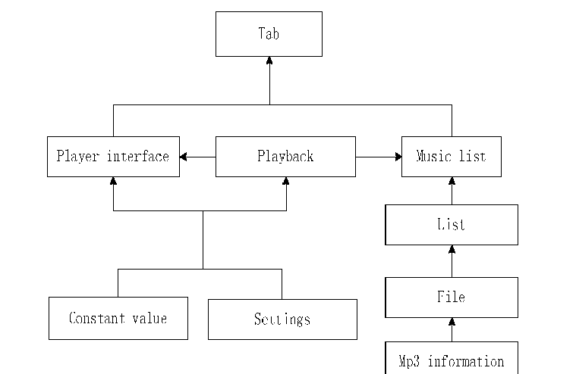

**(b) Working Diagram**

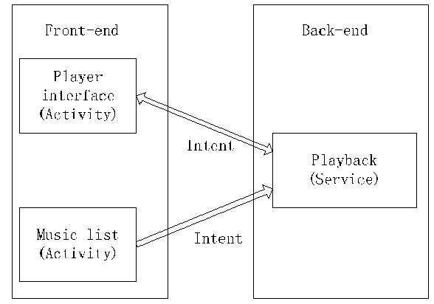

## 5.2 Interfaces

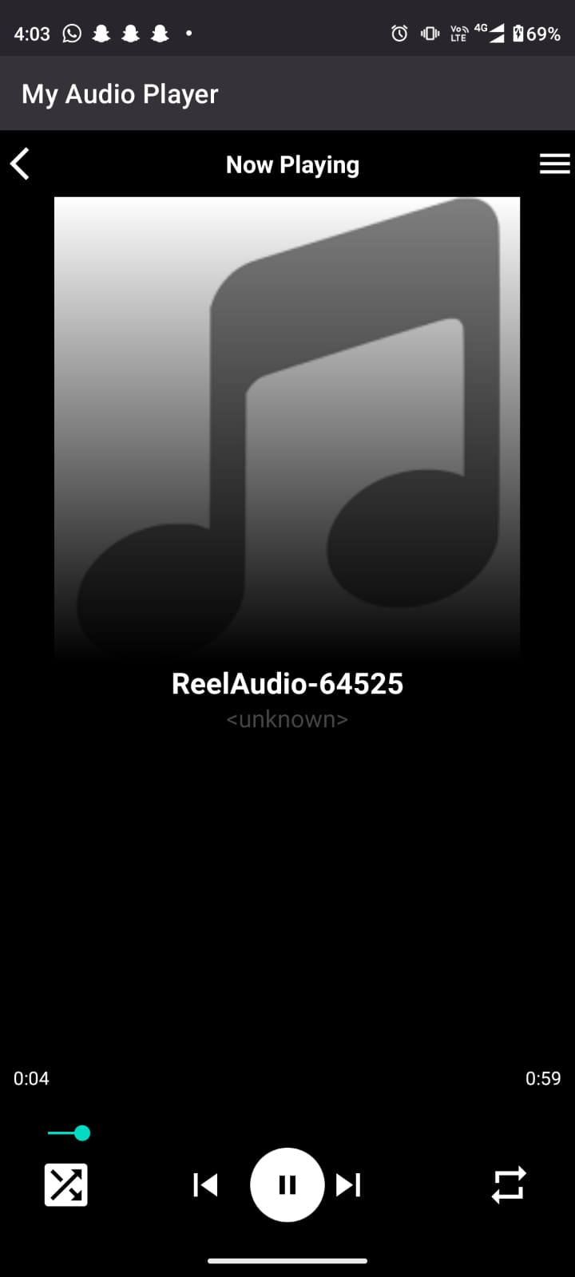 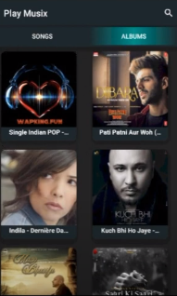 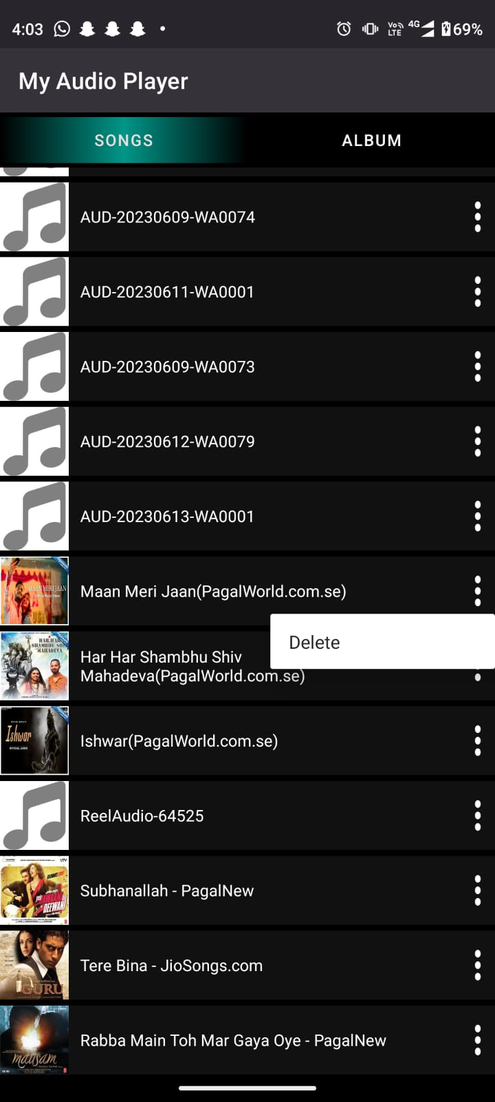

# 6. Performance Test

The performance test section evaluates the behaviour and efficiency of the music player application under various usage scenarios. By conducting these tests, we aim to assess the application's responsiveness, resource utilization, and overall user experience. This section provides a detailed overview of the test environment, scenarios, metrics measured, results obtained, and strategies implemented for optimization.

Although this project may not look like a fully functioning application so far, but this project can be considered as a prototype for developing a fully-fledged application.

**Test Environment**

The performance tests were conducted on an Android device with the following specifications:

**• Device Model:** Moto g52

**• Android Version:** Android 12

**• RAM:** 6 GB

**Test Scenarios**

The following scenarios were tested to evaluate the performance of the music player application:

1. Launching the application and navigating through the user interface.
2. Playing songs of varying file sizes and formats (MP3, FLAC).
3. Simulating heavy usage with concurrent operations (playing, skipping, and searching).

**Metrics Measured**

During the performance tests, the following metrics were measured and analysed:

1. **Responsiveness**: Time taken for the app to respond to user interactions.
2. **Loading Time**: Duration of the app launch and display of the main screen.
3. **Playback Efficiency**: Smoothness and stability of audio playback, including buffering.
4. **Memory Usage**: Amount of memory consumed by the app during different tasks.
5. **CPU Usage**: Utilization of the device's CPU under various scenarios.
6. **Battery Consumption**: Impact of the app on device battery life.

## 6.1 Test Plan/Test Cases and Test Procedures

**1. Functional Test Cases**

Test Case 1.1: Song Playback

1. Open the app.
2. Select a song from the library.
3. Verify that the song starts playing.
4. Pause the playback.
5. Verify that the song pauses.
6. Resume the playback.
7. Verify that the song resumes from where it was paused.

**2. Usability Test Cases**

**Test Case 2.1: UI Navigation**

1. Open the app.
2. Navigate through different screens (library, playlist, settings).
3. Verify that UI elements are consistent and intuitive.

**3. Performance Test Cases**

**Test Case 3.1: Loading Time**

1. Measure the time it takes to launch the app.
2. Verify that the app launches within an acceptable time frame.

## 4. Integration Test Case

## Test Case 4.1: UI-Backend Interaction

## Play a song.

## Verify that the UI displays the correct song information.

## Test Case 4.2: API Integration

## Search for a song.

## Verify that search results are displayed accurately.

## 6.2 Performance Outcome

**Test Case 6.2.1:** Loading Time

**Test Objective**: To verify that the app launches within an acceptable time frame.

**Test Outcome**: The app launched within the expected time frame, meeting the performance criterion.

**Test Case 6.2.2**: Responsiveness during Playback

**Test Objective**: To verify that the app responds promptly during song playback.

**Test Outcome**: The app exhibited prompt responsiveness to user actions during song playback.

**7. My learnings**

Throughout the whole month that I spent working on this project due to the internship opportunity given by upskill Campus, I learnt a lot of skills in many ways, including not only technical skills but also project report making, time management, trying to indulge into work like a corporate professional and many others that may be could not be mentioned but have been acquired by my own self.

Talking about this project, I learnt how to use Android Studio using Java technology. These technologies are in high demand these days, so acquiring them will be surely beneficial for me.

The project presented me with numerous challenges that required innovative problem-solving. Debugging, troubleshooting, and finding efficient solutions became second nature. I learned to approach issues systematically, breaking down complex problems into manageable components.

Throughout the project, we realized that technology is ever-evolving. Staying up-to-date with the latest advancements in Java, and Android Development practices became a continuous endeavour.

In conclusion, the "My Learning" section encapsulates the growth, challenges, and achievements that marked my journey through the development of the Music Player Application Project. The lessons gained from this experience are invaluable, serving as a foundation for my continuous growth as a software developer and a problem solver.

# 8. Future work scope

While the current version of the Music Player Application has successfully achieved its initial goals, there are several areas where future work can enhance the application's functionality, user experience, and overall value. The following are potential areas for future development and improvement:

**1.** **Enhanced User Interface and Design**

Implement a more modern and visually appealing user interface (UI) design.

Explore themes and customization options to cater to diverse user preferences.

Incorporate animations and transitions to provide a smoother and more engaging user experience.

**2. Advanced Search and Recommendation**

Integrate advanced search algorithms to improve song search accuracy.

Implement personalized song recommendations based on user listening history and preferences.

Provide dynamic playlists based on moods, genres, or user-defined criteria.

**3. Cloud Integration and Synchronization**

Enable cloud storage integration to allow users to access their music libraries across devices.

Implement synchronization capabilities to ensure playlists and preferences remain consistent.

**4. Social Sharing and Interaction**

Integrate social sharing features to allow users to share their favourite songs and playlists.

Implement social interaction capabilities, such as following other users and collaborative playlists.

**5. Enhanced Audio Features**

Incorporate an equalizer for users to adjust audio settings based on their preferences.

Implement support for various audio formats and codecs to expand compatibility.

The future work scope for Music Player Application presents exciting opportunities to enhance its features and capabilities. By addressing these areas, the application can continue to evolve and provide users with an even more enjoyable and comprehensive music listening experience.